**SOFTWARE REQUIREMENT SPECIFICATION**

**AMIGOS HOSPITAL**

The SRS is produced at the culmination of the analysis task. The SRS is technical specification of requirements of Hospital.

Undertaking various registrations. HMS is able to facilitate various registration needs in a hospital. ...

**Purpose:**

The main purpose of our system is to make hospital task easy and is to developed login page, Employee Form and Hospital stock. This document serves as the unambiguous guide for the developers of this software system. First and foremost, management software should have hospital registration software to provide the possibility to register patients into the hospital’s system and file in all relevant information.

**Scope:**

The document only covers the requirement specification for the hospital management system. This document does not provide any references to the other component of the hospital management system. All the external interfaces and the dependencies are also identified in this document.

**SPECIFIC REQUIREMENTS:**

It describes all the details that the software developer need to know for designing and developing the system. This is typically the largest and most important part of the document. External Interface

**Contents:**

1. Software’s Required
2. Html(Hyper Text Mock-up Language)
3. Css(Cascading Style Sheet)
4. Bootstrap
5. MySQL
6. Python
7. Django
8. JavaScript

**Abstract:**

The Hospital Form is a document that is used to gather information about a login user and manager, in employee form new employee details, including their personal and contact information, as well as their employment history, and job-related preferences. The purpose of the form is to create a comprehensive profile of the employee that can be used to manage their employment and help them integrate into their new role. The form typically includes fields for name, address, phone number, email, specialization, work experience, job title, start date, and emergency contact information, among others. This form is important for Manager and payroll purposes and is usually filled out during the on boarding process.

**TEAM MEMBERS:**

* M.YOGEE
* O.DINESH
* S.CHANDRA
* C.HARISH
* K.SNEHA
* L.SHIVANI
* B.NIKHIL

**Task:**

* We have to create the login form page in Html and we have to give the login details (User and Manager Details).
* We have to create the project in Django
* We have to create the Database by MySQL
* We have to link the Html page & Django application.
* We have to give login access to User and Manager
* User and Manager Details present in Database we have to do.
* We have to do pagination for Employee Details give to database.

**Software Required:**

|  |  |
| --- | --- |
| **Software Required** | **Versions** |
| HTML | HTML 5 |
| CSS | CSS3 |
| Bootstrap | Bootstrap 4 |
| Mysql | 8.0.32 |
| Python | Python 3.11 |
| Django | 4.1.6 |
| JavaScript | Es6 |
| OS | Windows 11 |

**HTML & CSS:**

* HTML5 is the fifth revision of the HTML standard and brings a range of new features and capabilities to web development.
* Some of the most notable features include improved support for multimedia content, such as video and audio, new semantic elements to describe different parts of a web page, and improved support for offline web applications.
* CSS3, on the other hand, is the latest version of the style sheet language used to describe the look and formatting of a web page. It provides a range of new selectors, properties, and techniques for creating modern, dynamic, and responsive web pages. Some of the most notable features in CSS3 include support for responsive design, new layout an positioning techniques, and advanced effects and animations.
* Together, HTML5 and CSS3 provide a powerful platform for creating modern, dynamic, and engaging websites and web applications.
* By using Html5& Css3 we have developed following web pages:
* Login.html
* Userhomepage.html
* Managerhomepage.html

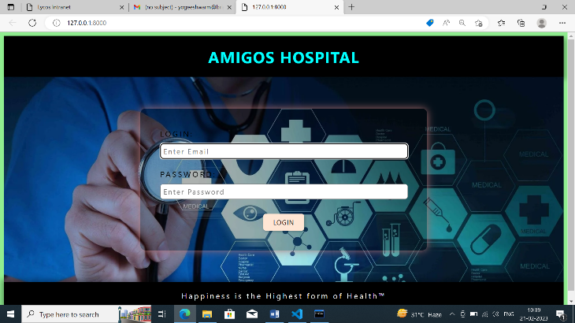

Fig1.Login page

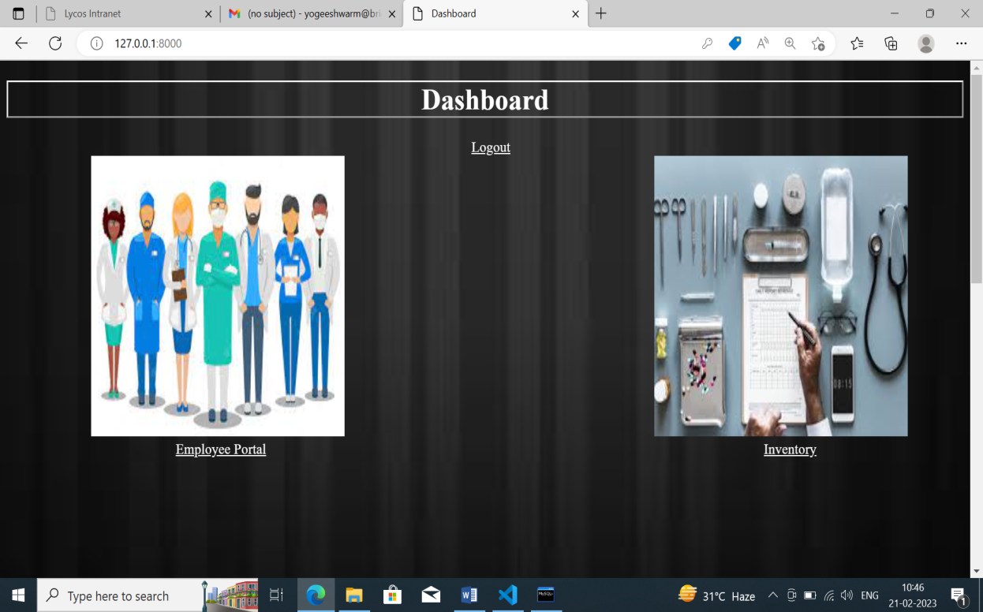

**Fig2.Userhomepage**

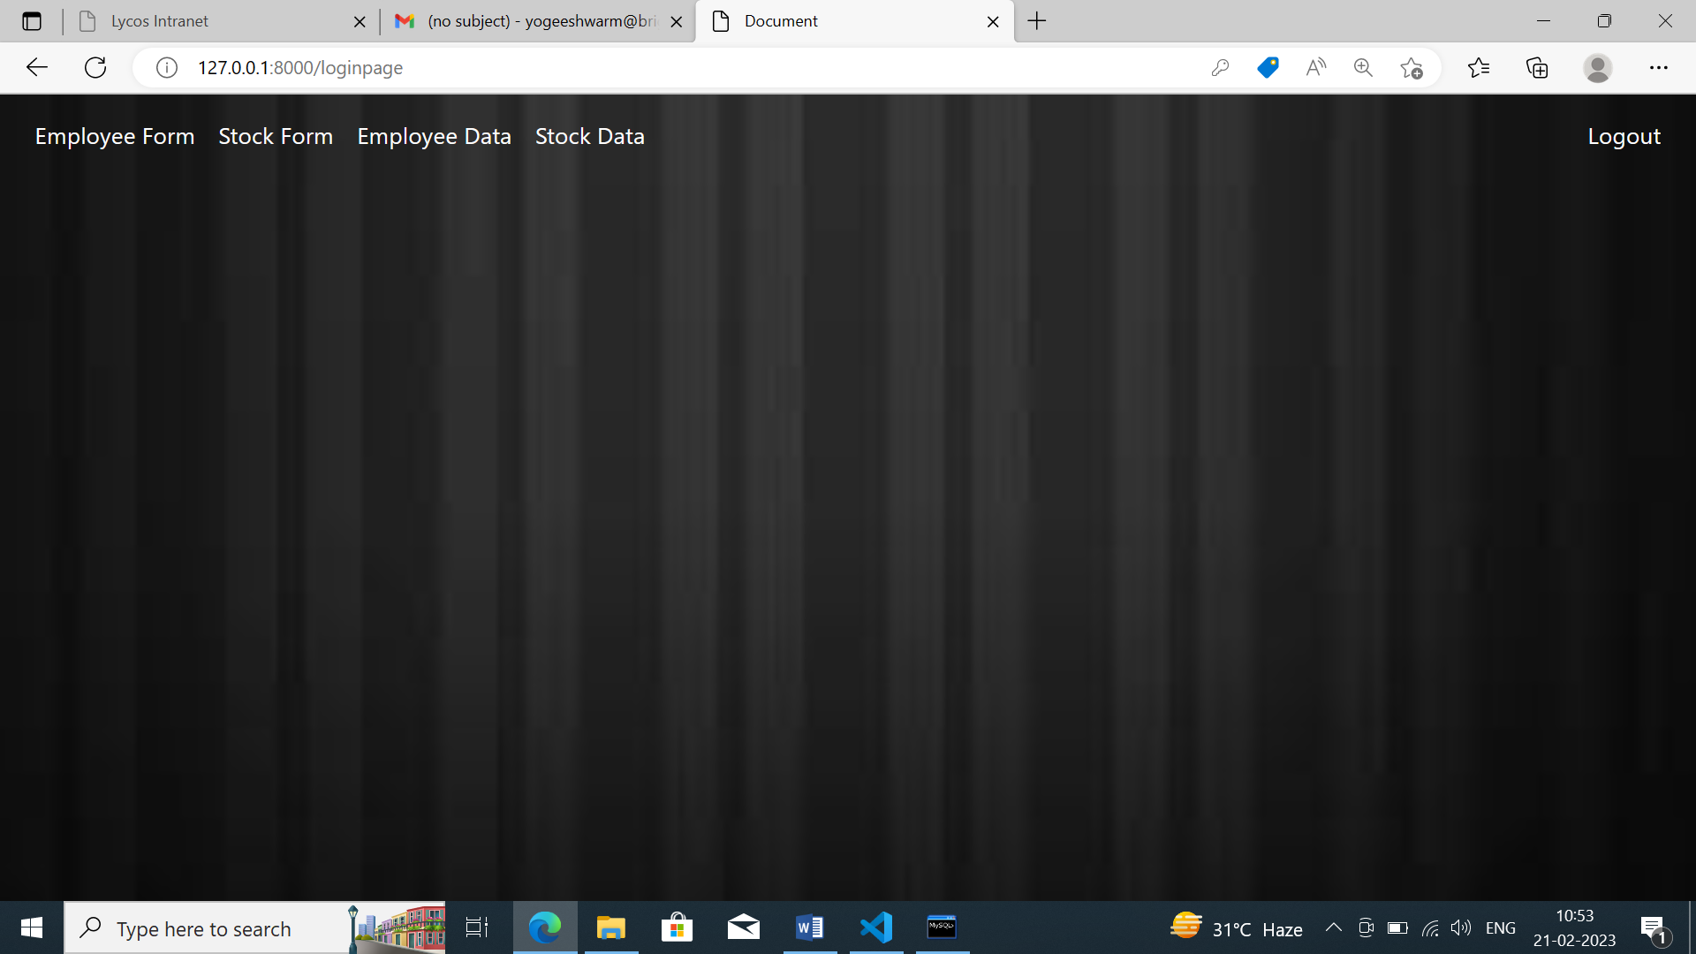

**Bootstrap:**

Bootstrap is a popular open-source front-end framework used for developing responsive and mobile-first websites and web applications. It was developed by Twitter and was originally released in 2011.

Bootstrap is based on HTML, CSS, and JavaScript and provides a set of pre-designed components, such as navigation bars, buttons, forms, and modals, that can be easily added to a project to create a user-friendly interface. It also provides a grid-based layout system that makes it easy to create responsive, multi-column designs.

Bootstrap also includes a number of CSS classes that can be used to style elements on a page and to implement various design elements, such as typography, colours, and spacing.

The framework also supports JavaScript plugins for adding interactivity to a page, such as dropdown menus and carousels.

Bootstrap is widely used by developers and designers for its simplicity and versatility. It allows for quick and easy prototyping, and can be customized to fit the specific needs of a project.

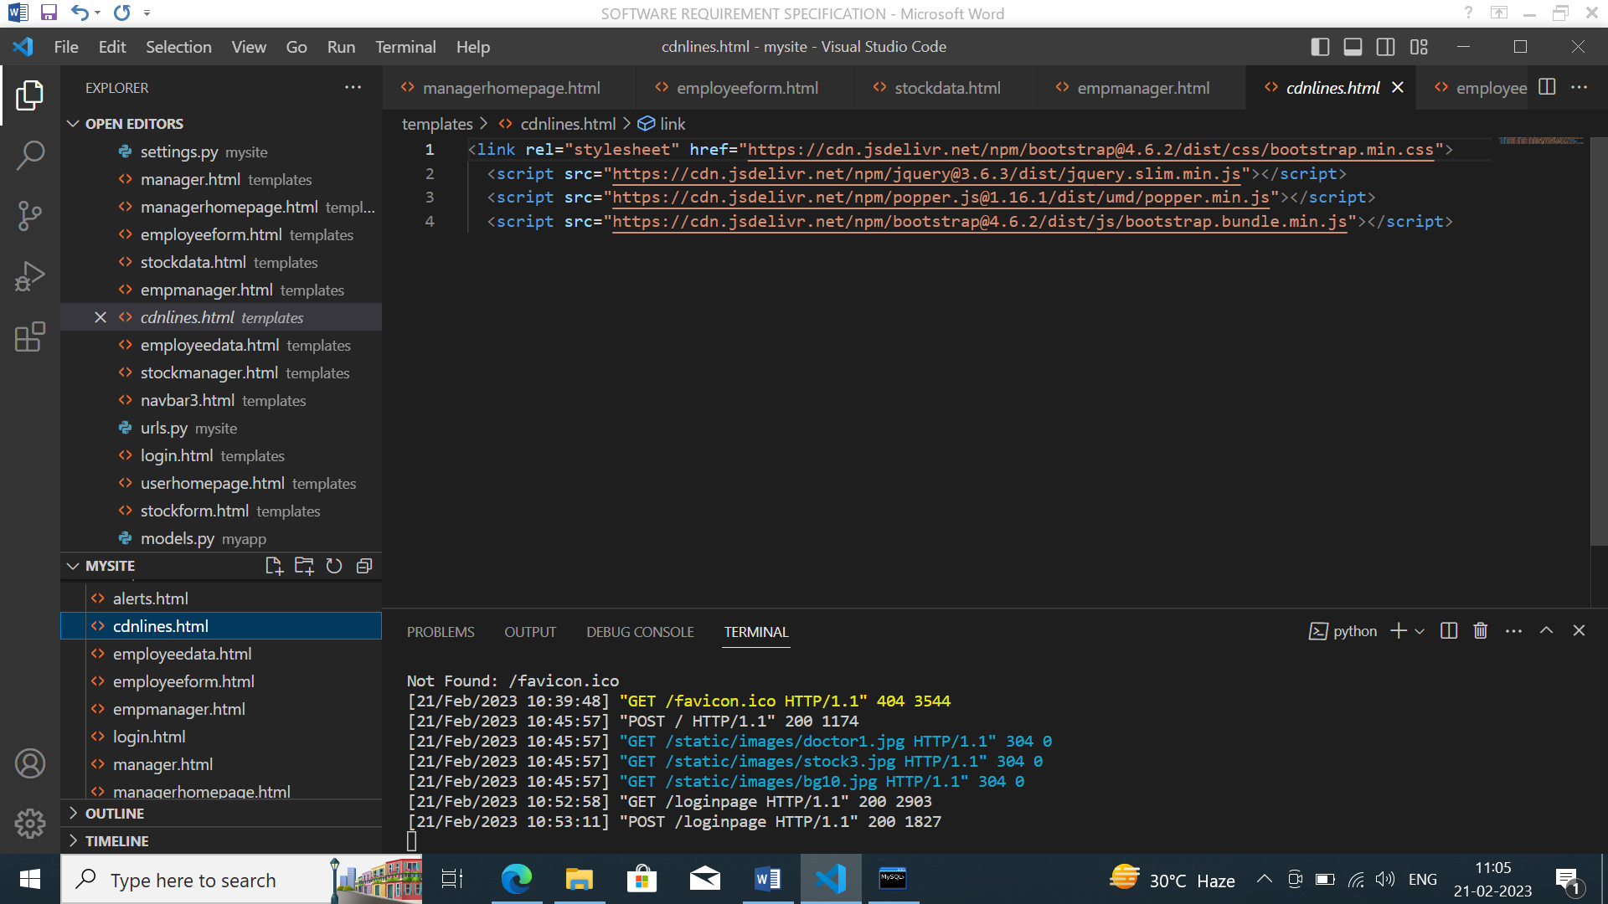

Fig4:Bootstrap

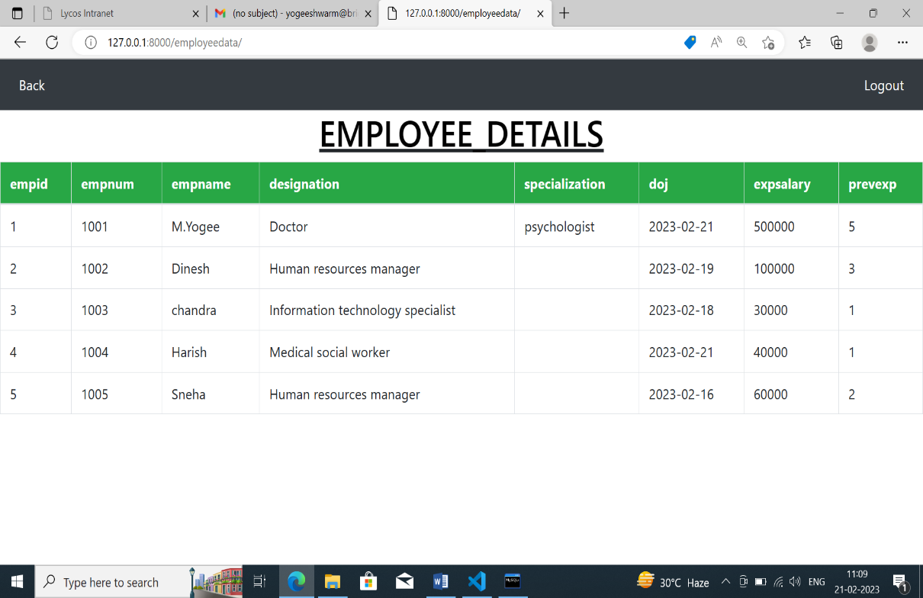

**FORMS:**

Forms are used to collect the required information. A form in access is a database object that you can use to create user interface for a database applications.

* **Employee Form**

In Amigos Hospital ,we design employee form to gather the details of employees.

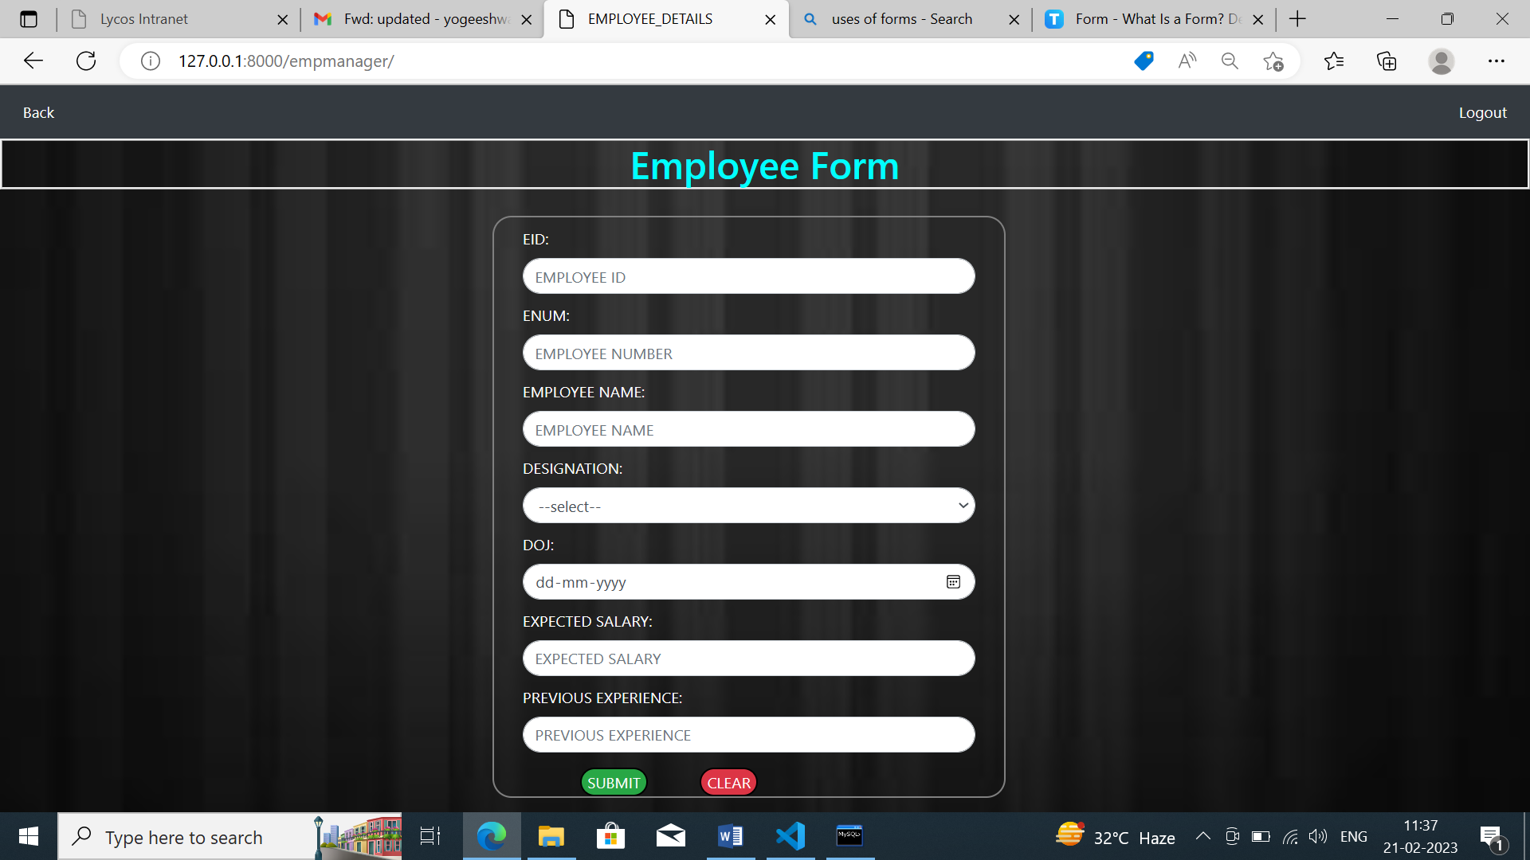

Fig6: Employee Form

* **Stock Form**

Stock form uses Periodic Automatic Replenishment or PAR levels and expiration date tracking to monitor all transactions in real time.

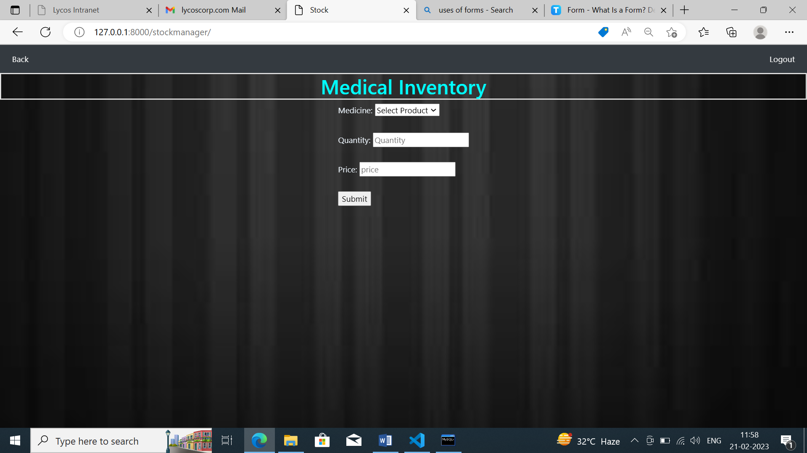

Fig7: Stock Form

**Python & Django :**

**DJANGO:**

Django is a framework which is used to create/design web-application. django is 3rd party module

1. **Django Features:**

* We can create any application with in less time.
* Django is versatile framework because we can create any kind of domine (sales, health........) websites.
* Django is more securable because lot of pre-define code with more security.
* Django supports all databases like mysql, sql,.........
* Django is portable framework.

1. **Django Application:**

* Django project is a collection of applications along with their configurations.
* A project must require at least one application and almost n number of application.
* Django-admin.py file will be installed automatically where we install django.

**Syntax:**

* django-admin start project <project name>
* An application is a specific task of the project.

**Manage.py:**

* manage.py file will be creating automatically whenever we create project.
* We use manage.py file to create django application.
* Also use startapp command along with manage.py file to create django application.

**Syntax:**

* python manage.py startapp <appname>

**General points:**

• Django follows MVT model

M----->model-------------->to write databases related code.

V------->views------------> to write business related code.

T------>templates-------->to write presentation related code .

**Start project :**

step1: settings.py:

 1. installapp:

'appname';

 2.databases:

 DATABASES = {

 'default': {

 'ENGINE': 'django.db.backends.mysql',

 'NAME': 'mydb',

 'USER': 'yogee',

 'PASSWORD': 'yogee@123',

 'HOST':'192.168.30.88',

 'PORT':'3306',

 }

}

 3.import os

 4.TEMPLATES_DIR=os.path.join(BASE_DIR,'templates')

5.temlates:

 dir=[TEMPLATES_DIR]

**step2: MODELS.py:**

* A model is python class which is used to create database table.
* We can use class keyword to create django class.
* Models.Model is base class for every user defined class.
* Model is a collection of python class keyword, classname, field name and field type.
* Use makemigrations and migrate commands to convert django model into database table.

**Makemigrations:**

**syntax:**

* Python manage.py makemigrations.

1. We run the make migrations command in terminal then django will go to models.py file and check for latest modifications.

2. If any migrations are in orm language then it will be converted into sql language.

**Migrate:**

**syntax:**

* python manage.py migrate

1. It will create a new python file in migrations folder and  save the sql code.

2. If any python file available in models.py then it will take  sql code from that file and execute the database,so it will  create table as per django model.

**step 3: Views.py**:

1. A views is python function which takes http request and executes the views body and returns http Response.  2. We use a def keyword to create views

3. Every view ends with any one of the following function:

• Render:

* return httpRequest from the templates.

• HttpResponse:

* returns the httpRequest to browser as

httpResponse.

4. We use conditional statements to receive the type of request like GET or POST.

• GET:------------->GET requests are only used to request  data.

• POST:------------>POST is stored in the request body of  the HTTP request.

• SORT :-----------> sort is used to descending and ascending by specific column.

**step4: Templates:**

• templates means .html file

• {{}}------>To write variable name.

• { % %}-------->To add link one page to another page.

**step5:urls.py:**

 It contains all the names and path of views which help to redirect to views.

**step6: runserver**

**syntax:**

* python manage.py runserver.

**JavaScript:**

JavaScript is a high-level, interpreted programming language that is widely used for front-end web development. It is used to add interactivity, dynamic behaviour, and other advanced features to websites. JavaScript runs in the user's web browser, allowing for a dynamic and interactive user experience.

JavaScript can be used for a variety of tasks, including:

Form validation: JavaScript can be used to check if a user has entered valid information into a form before it is submitted.

Dynamic content updates: JavaScript can be used to update content on a web page without having to reload the entire  page.

Animations and effects: JavaScript can be used to create animations, such as sliding images or fading text, and other  visual effects.

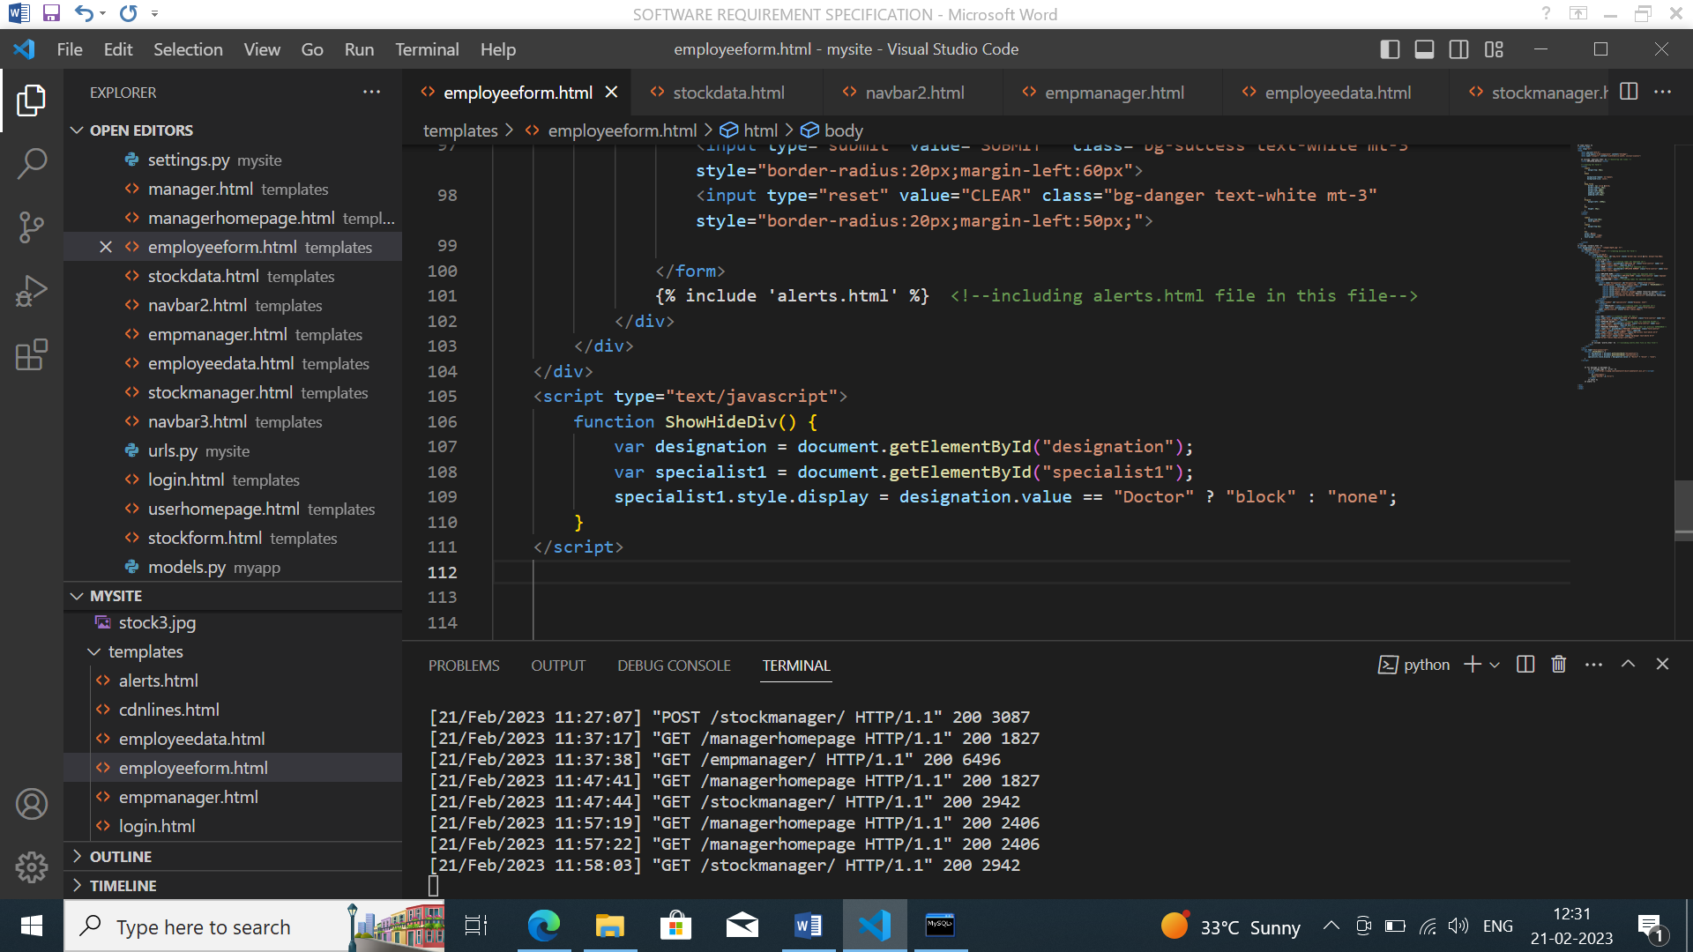

Fig8:Javascript.

**MySQL:**

MySQL is a widely-used open-source relational database management system (RDBMS). It is used for storing, organizing, and retrieving data in a structured way. MySQL is a popular choice for web-based applications, as it is fast,  reliable, and easy to use.

MySQL is based on the Structured Query Language (SQL), which is used to create, manipulate, and query the data stored in a database. In MySQL, data is stored in tables, which consist of rows and columns. Each row represents a single record, and each column represents a specific field of data.

MySQL provides a number of features that make it a powerful tool for managing data, including:

• Data security: MySQL provides a number of security features to ensure the protection of data stored in a  database, including user authentication and access  control.

• Scalability: MySQL can handle large amounts of data  and can easily be scaled up to support growing  amounts of data.

• High performance: MySQL is optimized for fast  performance and can handle large amounts of data  and concurrent users.

• Cross-platform support: MySQL runs on a variety of  platforms, including Windows, macOS, and Linux,  and can be used with a wide range of programming  languages, including PHP, Java, and Python.

Overall, MySQL is a widely-used and reliable database  management system that is well suited for web-based  applications and other data-intensive projects.

Note: we have to create Database by following Quary

To connect database remotely we have to run following  commands in our mysql database:

• create user 'root'@'%' identified by 'admin';  • grant all privileges on *.* to 'root'@'%' with grant  option;

• flush privileges;

we have to configure database in settings.py

We have to create table in modules.py by using following  quary in mysql: create database formdb;

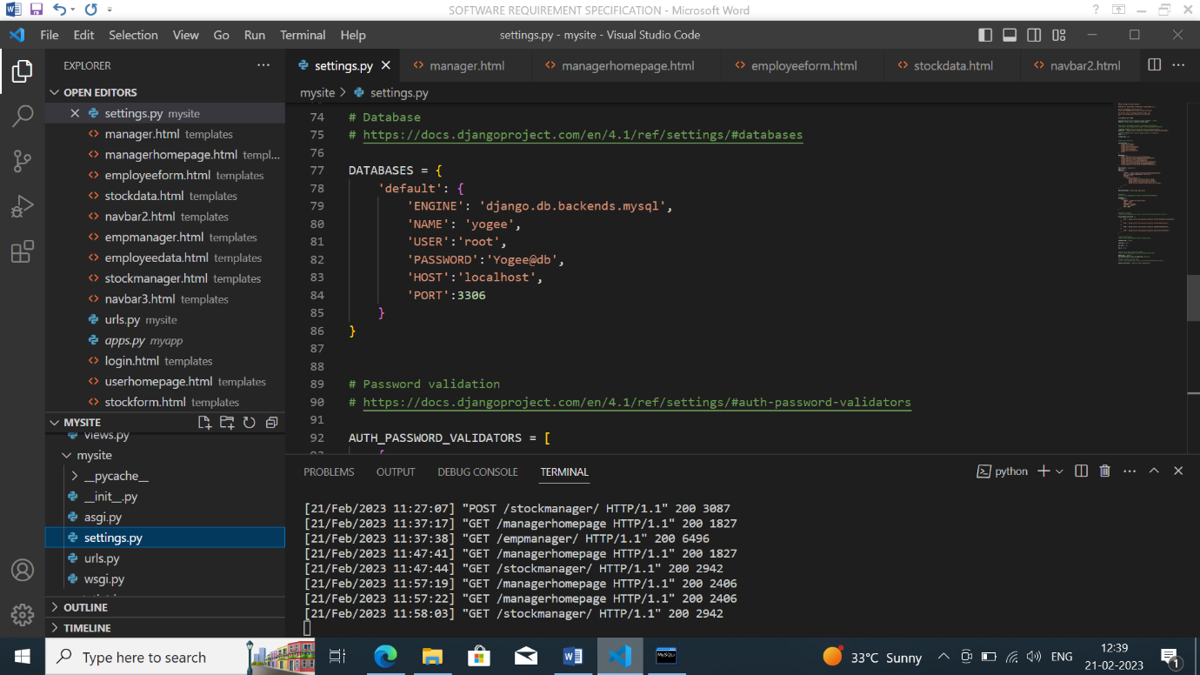

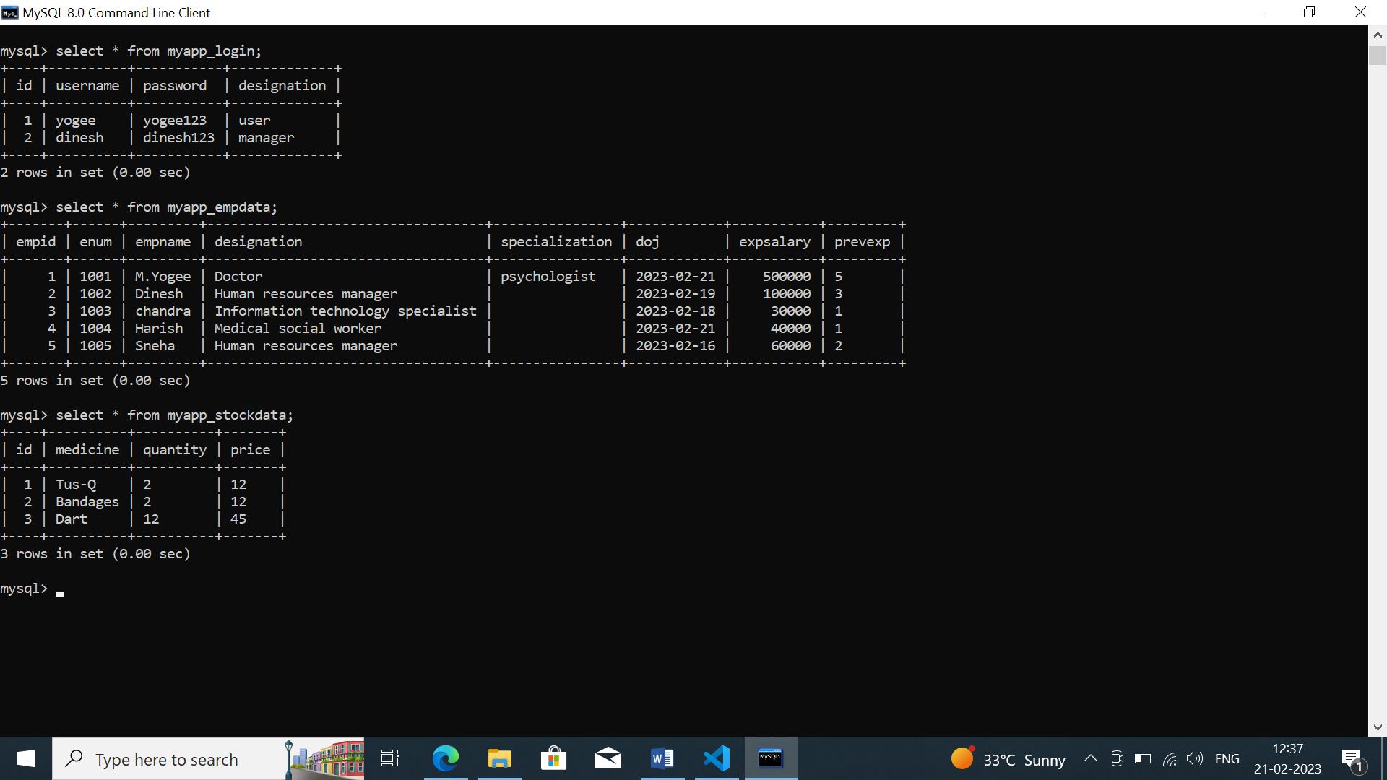

**Conclusion:**

The login page with employee form and stock form is an essential tool for Organisation to manage the employee details and stock form in their organization. It allows them to easily add new employees to the system and view the details of existing employees. This documentation has provided an overview of the Manager Login page and the features available on the employee form and stock form pages.